**LAB 3**

**Q1) List one special function of each of the data registers AX. BX, CX, and DX.**

**AX:** Used in arithmetic instructions.

**BX:** Used in indexed addressing.

**CX:** Stores loop count in iterative operations.

**DX:** Used in multiplication/division of large values.

**Q2)** **What is a paragraph boundary? (Reading Assignment)**

Any memory address evenly divisible by 16 is called a paragraph boundary.

**Q3) Write instructions that perform the following operations:**

**a. Copy BL into CL**

**b. Copy DX into AX**

**c. Store 0x08 into AL**

**d. Store 0x3421 into AX**

**e. Store 0xFFBC into AX**

**a.** mov CL, BL

**b.** mov AX, DX

**c.** mov AL, 0x08

**d**. mov AX, 0x3421

**e.** mov AX, 0xFFBC

Program:

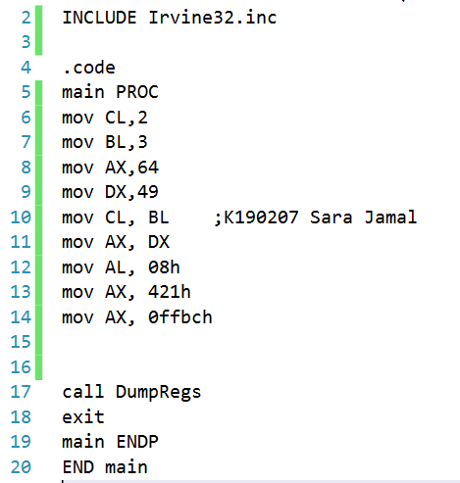

Output:

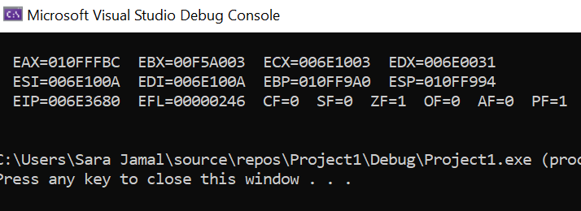

**Q4)** **Create an uninitialized data declaration for a 64-bit integer.**

var1 DQ?

**Q5)** **Declare a 32-bit signed integer val3 and initialize it with the smallest possible negative**

**decimal value.**

val3 SDD -2147483648

**Q6)** Program:

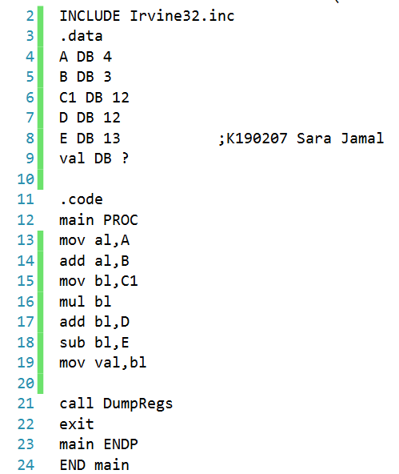

Output:

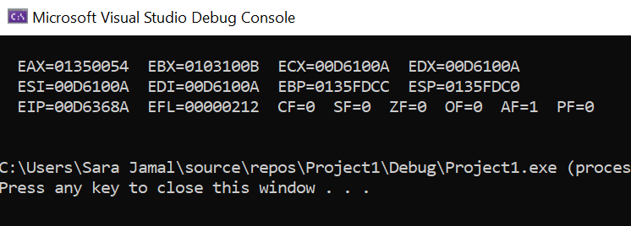

**Q7)** **Fill in the following tables to show storage of 0xDADABABAat address 1996 in the**

**memory of a machine using (i) little endian (ii) big endian byte ordering.**

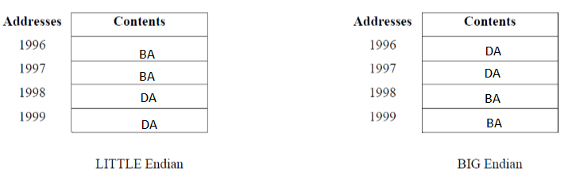

**Q8)** **What will be the values of the Overflow, Sign, and Zero flags after the following**

**instructions have executed?**

**mov cx,-4097**

**add cx,1001h**

Output:

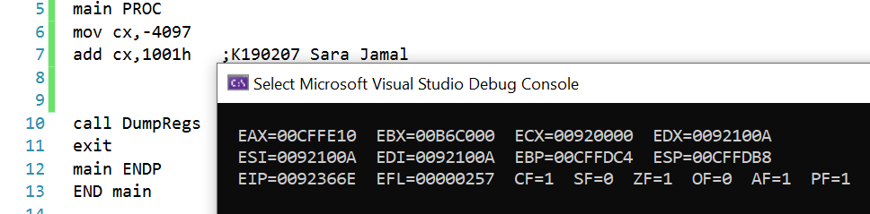

OF=0

SF=0

ZF=1

**Q9) What will be the value of the Sign flag after following instruction**

**sequences has executed?**

**A. mov cx,8000h**

**add cx,A69Fh**

SF=0

**B.** **Solve the Q9(A) in binary format and fill the below register values.**

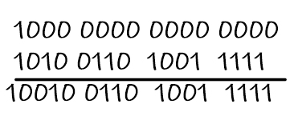

CF=1

PF=1

AF=0

ZF=0

SF=0

OF=1

**Q10)** Program:

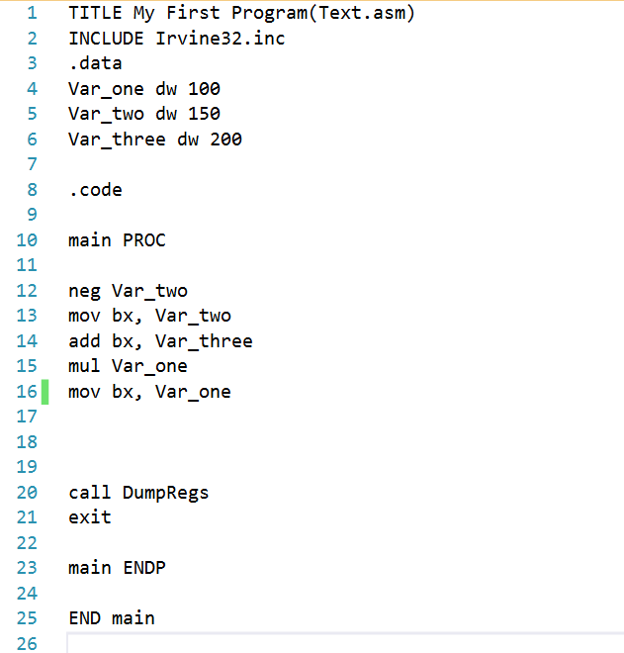

Output:

